**NAME:** Salveeka Gurung

**LBU ID:** 77261102

**LEVEL:** 6 (1st Sem)

**SUBJECT:** Advanced Web Engineering

**COMPONENT 2**

**DOCUMENTATION:**

LARAVEL INSTALLATION:

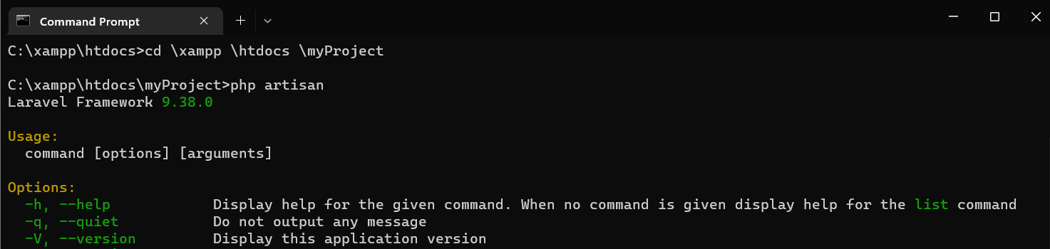

LARAVEL LIVE SERVER:

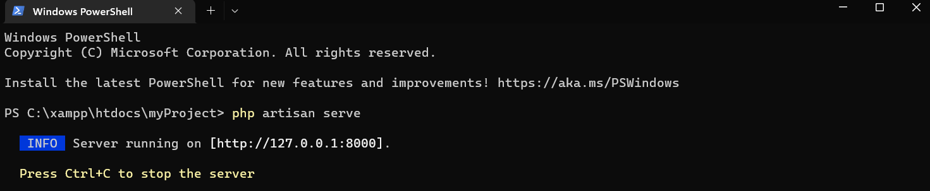

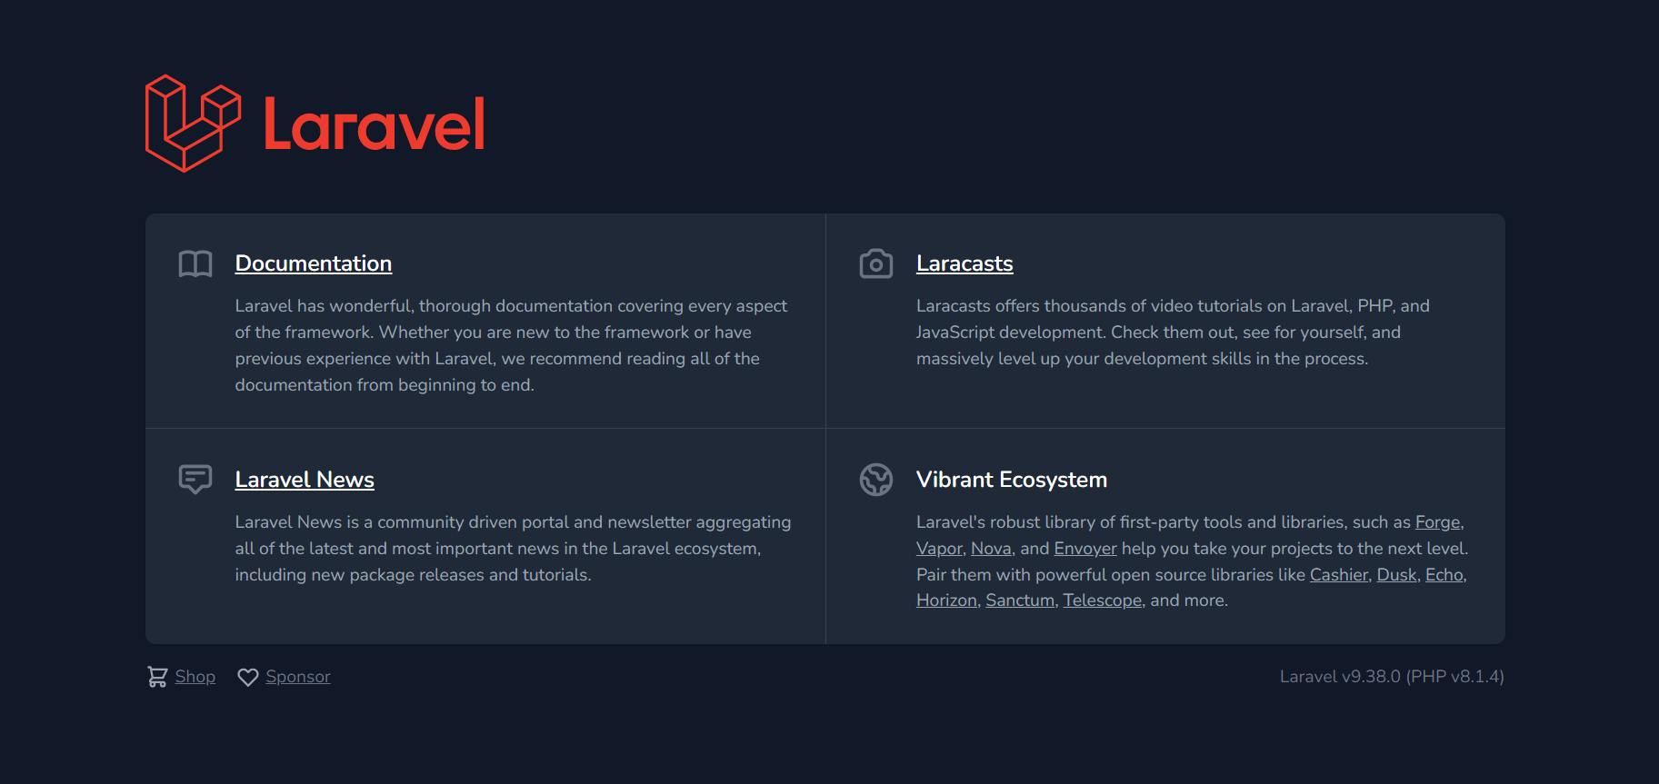

ROUTING FOR HTTP ACTION/VERBS:

1. GET:

1. POST :



1. WILDCARD :

1. WILDCARD CONSTRAINTS :

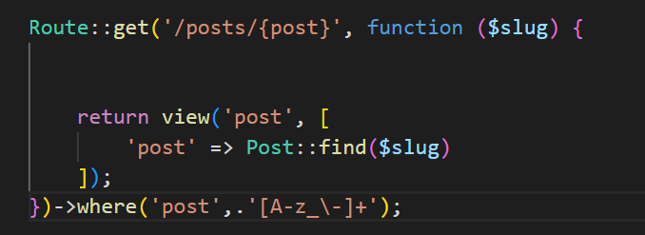

1. VIEW COMPONENT WITH BLADE COMPONENTS :

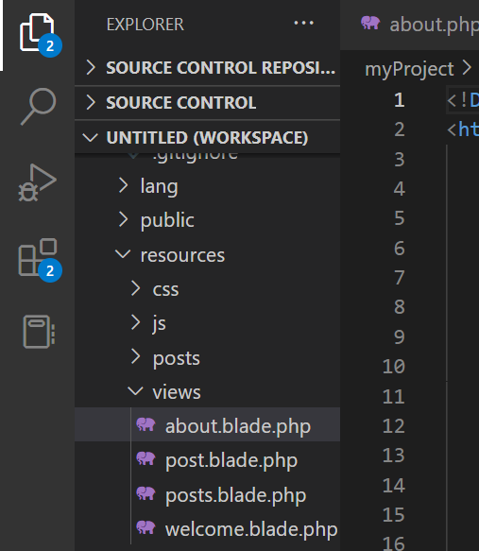

1. COLLECTION :

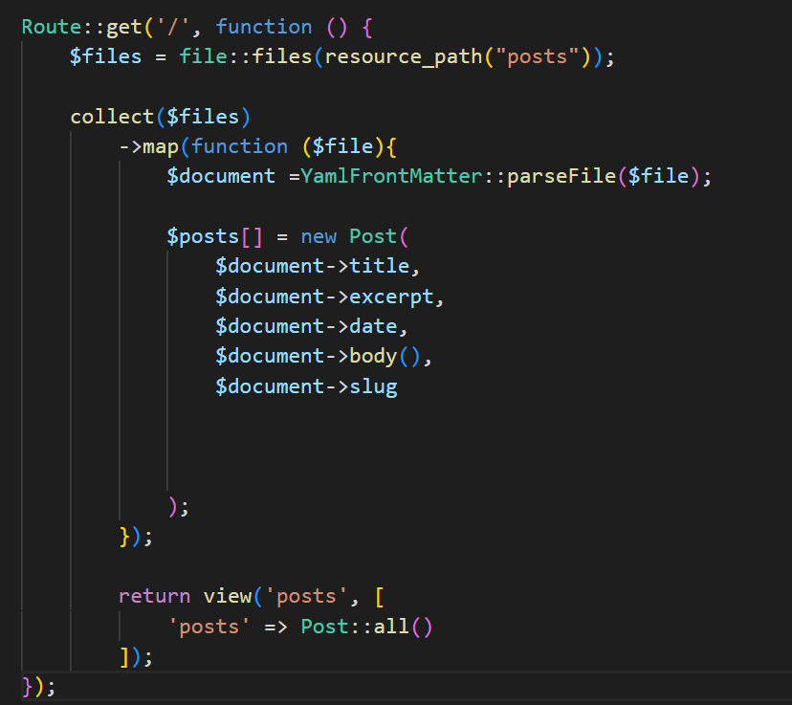

1. CACHING :

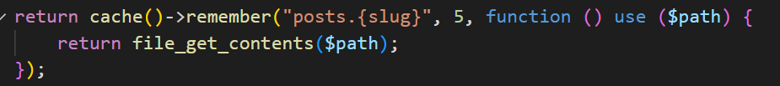

1. SORTING :

